library(bayesrules)
Warning message:
The `size` argument of `element_line()` is deprecated as of ggplot2 3.4.0.
ℹ Please use the `linewidth` argument instead.
ℹ The deprecated feature was likely used in the rstan package.
Please report the issue at <https://github.com/stan-dev/rstan/issues/>.
This warning is displayed once every 8 hours.
Call `lifecycle::last_lifecycle_warnings()` to see where this warning was generated.
>
> library(tidyverse)
── Attaching packages ────────────────────────────────────────────────────────────────────── tidyverse 1.3.2 ──
✔ ggplot2 4.0.0 ✔ purrr 1.0.1
✔ tibble 3.3.0 ✔ dplyr 1.1.4
✔ tidyr 1.3.0 ✔ stringr 1.5.0
✔ readr 2.1.4 ✔ forcats 1.0.0
── Conflicts ───────────────────────────────────────────────────────────────────────── tidyverse_conflicts() ──
✖ dplyr::filter() masks stats::filter()
✖ dplyr::lag() masks stats::lag()
> library(rstanarm)
Loading required package: Rcpp
This is rstanarm version 2.21.3
- See https://mc-stan.org/rstanarm/articles/priors for changes to default priors!
- Default priors may change, so it's safest to specify priors, even if equivalent to the defaults.
- For execution on a local, multicore CPU with excess RAM we recommend calling
options(mc.cores = parallel::detectCores())
> library(broom.mixed)
> data(cherry_blossom_sample)
>
> write.csv(cherry_blossom_sample, "cherry_blossom_sample.csv")
> running <- cherry_blossom_sample %>%
+ select(runner, age, net)
> nrow(running)
[1] 252
> ggplot(running, aes(x = runner, y = net)) +
+ geom_boxplot()
Warning message:
Removed 67 rows containing non-finite outside the scale range (`stat_boxplot()`).
>
> head(running, 2)
# A tibble: 2 × 3
runner age net
<fct> <int> <dbl>
1 1 53 84.0
2 1 54 74.3
> ggplot(running, aes(y = net, x = age)) +
+ geom_point()
Warning message:
Removed 67 rows containing missing values or values outside the scale range (`geom_point()`).

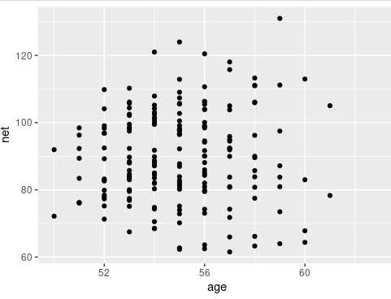

complete_pooled_model <- stan_glm(
+ net ~ age,
+ data = running, family = gaussian,
+ prior_intercept = normal(0, 2.5, autoscale = TRUE),
+ prior = normal(0, 2.5, autoscale = TRUE),
+ prior_aux = exponential(1, autoscale = TRUE),
+ chains = 4, iter = 5000*2, seed = 84735)

SAMPLING FOR MODEL 'continuous' NOW (CHAIN 1).
Chain 1:
Chain 1: Gradient evaluation took 0.000714 seconds
Chain 1: 1000 transitions using 10 leapfrog steps per transition would take 7.14 seconds.
Chain 1: Adjust your expectations accordingly!
Chain 1:
Chain 1:
Chain 1: Iteration: 1 / 10000 [ 0%] (Warmup)
Chain 1: Iteration: 1000 / 10000 [ 10%] (Warmup)
Chain 1: Iteration: 2000 / 10000 [ 20%] (Warmup)
Chain 1: Iteration: 3000 / 10000 [ 30%] (Warmup)
Chain 1: Iteration: 4000 / 10000 [ 40%] (Warmup)
Chain 1: Iteration: 5000 / 10000 [ 50%] (Warmup)
Chain 1: Iteration: 5001 / 10000 [ 50%] (Sampling)
Chain 1: Iteration: 6000 / 10000 [ 60%] (Sampling)
Chain 1: Iteration: 7000 / 10000 [ 70%] (Sampling)
Chain 1: Iteration: 8000 / 10000 [ 80%] (Sampling)
Chain 1: Iteration: 9000 / 10000 [ 90%] (Sampling)
Chain 1: Iteration: 10000 / 10000 [100%] (Sampling)
Chain 1:
Chain 1: Elapsed Time: 0.258772 seconds (Warm-up)
Chain 1: 0.344616 seconds (Sampling)
Chain 1: 0.603388 seconds (Total)
Chain 1:

SAMPLING FOR MODEL 'continuous' NOW (CHAIN 2).
Chain 2:
Chain 2: Gradient evaluation took 1.5e-05 seconds
Chain 2: 1000 transitions using 10 leapfrog steps per transition would take 0.15 seconds.
Chain 2: Adjust your expectations accordingly!
Chain 2:
Chain 2:
Chain 2: Iteration: 1 / 10000 [ 0%] (Warmup)
Chain 2: Iteration: 1000 / 10000 [ 10%] (Warmup)
Chain 2: Iteration: 2000 / 10000 [ 20%] (Warmup)
Chain 2: Iteration: 3000 / 10000 [ 30%] (Warmup)
Chain 2: Iteration: 4000 / 10000 [ 40%] (Warmup)
Chain 2: Iteration: 5000 / 10000 [ 50%] (Warmup)
Chain 2: Iteration: 5001 / 10000 [ 50%] (Sampling)
Chain 2: Iteration: 6000 / 10000 [ 60%] (Sampling)
Chain 2: Iteration: 7000 / 10000 [ 70%] (Sampling)
Chain 2: Iteration: 8000 / 10000 [ 80%] (Sampling)
Chain 2: Iteration: 9000 / 10000 [ 90%] (Sampling)
Chain 2: Iteration: 10000 / 10000 [100%] (Sampling)
Chain 2:
Chain 2: Elapsed Time: 0.234171 seconds (Warm-up)
Chain 2: 0.343013 seconds (Sampling)
Chain 2: 0.577184 seconds (Total)
Chain 2:

SAMPLING FOR MODEL 'continuous' NOW (CHAIN 3).
Chain 3:
Chain 3: Gradient evaluation took 2.5e-05 seconds
Chain 3: 1000 transitions using 10 leapfrog steps per transition would take 0.25 seconds.
Chain 3: Adjust your expectations accordingly!
Chain 3:
Chain 3:
Chain 3: Iteration: 1 / 10000 [ 0%] (Warmup)
Chain 3: Iteration: 1000 / 10000 [ 10%] (Warmup)
Chain 3: Iteration: 2000 / 10000 [ 20%] (Warmup)
Chain 3: Iteration: 3000 / 10000 [ 30%] (Warmup)
Chain 3: Iteration: 4000 / 10000 [ 40%] (Warmup)
Chain 3: Iteration: 5000 / 10000 [ 50%] (Warmup)
Chain 3: Iteration: 5001 / 10000 [ 50%] (Sampling)
Chain 3: Iteration: 6000 / 10000 [ 60%] (Sampling)
Chain 3: Iteration: 7000 / 10000 [ 70%] (Sampling)
Chain 3: Iteration: 8000 / 10000 [ 80%] (Sampling)
Chain 3: Iteration: 9000 / 10000 [ 90%] (Sampling)
Chain 3: Iteration: 10000 / 10000 [100%] (Sampling)
Chain 3:
Chain 3: Elapsed Time: 0.232679 seconds (Warm-up)
Chain 3: 0.342109 seconds (Sampling)
Chain 3: 0.574788 seconds (Total)
Chain 3:

SAMPLING FOR MODEL 'continuous' NOW (CHAIN 4).
Chain 4:
Chain 4: Gradient evaluation took 2.2e-05 seconds
Chain 4: 1000 transitions using 10 leapfrog steps per transition would take 0.22 seconds.
Chain 4: Adjust your expectations accordingly!
Chain 4:
Chain 4:
Chain 4: Iteration: 1 / 10000 [ 0%] (Warmup)
Chain 4: Iteration: 1000 / 10000 [ 10%] (Warmup)
Chain 4: Iteration: 2000 / 10000 [ 20%] (Warmup)
Chain 4: Iteration: 3000 / 10000 [ 30%] (Warmup)
Chain 4: Iteration: 4000 / 10000 [ 40%] (Warmup)
Chain 4: Iteration: 5000 / 10000 [ 50%] (Warmup)
Chain 4: Iteration: 5001 / 10000 [ 50%] (Sampling)
Chain 4: Iteration: 6000 / 10000 [ 60%] (Sampling)
Chain 4: Iteration: 7000 / 10000 [ 70%] (Sampling)
Chain 4: Iteration: 8000 / 10000 [ 80%] (Sampling)
Chain 4: Iteration: 9000 / 10000 [ 90%] (Sampling)
Chain 4: Iteration: 10000 / 10000 [100%] (Sampling)
Chain 4:
Chain 4: Elapsed Time: 0.233538 seconds (Warm-up)
Chain 4: 0.340647 seconds (Sampling)
Chain 4: 0.574185 seconds (Total)
Chain 4:

# Posterior summary statistics
> tidy(complete_pooled_model, conf.int = TRUE, conf.level = 0.80)
# A tibble: 2 × 5
term estimate std.error conf.low conf.high
<chr> <dbl> <dbl> <dbl> <dbl>
1 (Intercept) 75.2 24.6 43.7 106.
2 age 0.268 0.446 -0.302 0.842
> # A tibble: 2 x 5
> # Plot of the posterior median model
> ggplot(running, aes(x = age, y = net, group = runner)) +
+ geom_smooth(method = "lm", se = FALSE, color = "gray", size = 0.5) +
+ geom_abline(aes(intercept = 75.2, slope = 0.268), color = "blue")
`geom_smooth()` using formula = 'y ~ x'
Warning messages:
1: Using `size` aesthetic for lines was deprecated in ggplot2 3.4.0.
ℹ Please use `linewidth` instead.
This warning is displayed once every 8 hours.
Call `lifecycle::last_lifecycle_warnings()` to see where this warning was generated.
2: Removed 67 rows containing non-finite outside the scale range (`stat_smooth()`).
>

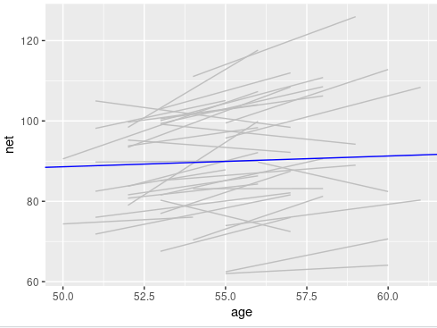
# Select an example subset
> examples <- running %>%

+ filter(runner %in% c("1", "20", "22"))
> ggplot(examples, aes(x = age, y = net)) +
+ geom_point() +
+ facet_wrap(~ runner) +
+ geom_abline(aes(intercept = 75.2242, slope = 0.2678),
+ color = "blue")
Warning message:
Removed 6 rows containing missing values or values outside the scale range (`geom_point()`).

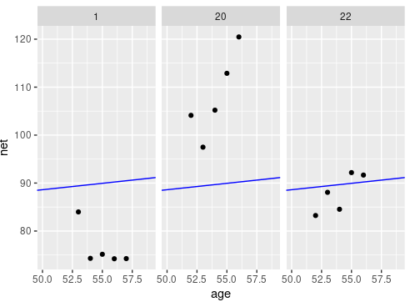

ggplot(examples, aes(x = age, y = net)) +
+ geom_point() +
+ geom_smooth(method = "lm", se = FALSE, fullrange = TRUE) +
+ facet_wrap(~ runner) +
+ xlim(52, 62)
`geom_smooth()` using formula = 'y ~ x'
Warning messages:
1: Removed 6 rows containing non-finite outside the scale range (`stat_smooth()`).
2: Removed 6 rows containing missing values or values outside the scale range (`geom_point()`).

